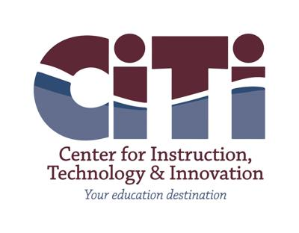

**Parent’s Bill of Rights**

* Parents (includes legal guardians or persons in parental relationships) and Eligible Students (student 18  years and older) can expect the following:

* 1. A student’s personally identifiable information (PII) cannot be sold or released for any commercial purpose. PII, as defined by Education Law § 2-d and FERPA, includes direct identifiers such as a student’s name or identification number, parent’s name, or address; and indirect identifiers such as a  student’s date of birth, which when linked to or combined with other information can be used to  distinguish or trace a student’s identity. Please see FERPA’s regulations at 34 CFR 99.3 for a more  complete definition.

* 1. The right to inspect and review the complete contents of the student’s education record stored or maintained by an educational agency. This right may not apply to parents of an Eligible Student.

* 1. State and federal laws such as Education Law § 2-d; the Commissioner of Education’s Regulations at 8 NYCRR Part 121, the Family Educational Rights and Privacy Act ("FERPA") at 12 U.S.C. 1232g (34 CFR Part 99); Children's Online Privacy Protection Act ("COPPA") at 15 U.S.C. 6501-6502 (16  CFR Part 312); Protection of Pupil Rights Amendment ("PPRA") at 20 U.S.C. 1232h (34 CFR Part 98);  the Individuals with Disabilities Education Act (“IDEA”) at 20 U.S.C. 1400 et seq. (34 CFR Part 300);  protect the confidentiality of a student’s identifiable information.

* 1. Safeguards associated with industry standards and best practices including but not limited to encryption, firewalls and password protection must be in place when student PII is stored or transferred.

* 1. A complete list of all student data elements collected by NYSED is available at <http://www.nysed.gov/data-privacy-security/student-data-inventory> and by writing to: Chief Privacy Officer, New York State Education Department, 89 Washington Avenue, Albany, NY 12234.

* 1. The right to have complaints about possible breaches and unauthorized disclosures of PII addressed. Complaints may be submitted to NYSED at <http://www.nysed.gov/data-privacy-security/report-improper-disclosure> , by mail to: Chief Privacy Officer, New York State Education Department, 89 Washington Avenue, Albany, NY 12234; by email to privacy@nysed.gov; or by telephone at 518-474- 0937. Complaints regarding student data breaches can also be directed to: Kristen Foland, Director of Instructional Support Services, Center for Instruction, Technology & Innovation, 179 County Route 64, Mexico NY, 13114. Phone: 315-963‐4425 email: kfoland@citiboces.org.

* 1. To be notified in accordance with applicable laws and regulations if a breach or unauthorized release of PII occurs.

* 1. Educational agency workers that handle PII will receive training on applicable state and federal laws, policies, and safeguards associated with industry standards and best practices that protect PII.

* 1. Educational agency contracts with vendors that receive PII will address statutory and regulatory data privacy and security requirements.